Create the Oracle Database User and Grant Privileges

Login with the user name/password: system/snap as sysdba
SQL>CREATE USER ttluzhen IDENTIFIED BY ttluzhen DEFAULT TABLESPACE users;
SQL>grant connect,resource,create any trigger to ttluzhen;
SQL>grant connect,resource,dba,create any trigger to ttluzhen;

Note: unloak the account HR.
SQL>ALTER USER HR ACCOUNT LOCK;
SQL>ALTER USER HR ACCOUNT UNLOCK;
SQL>ALTER USER HR IDENTIFIED BY newpassword;
SQL> SELECT value FROM nls_database_parameters WHERE parameter = 'NLS_CHARACTERSET';

Login with the user name/password: hr/newpassword as sysdba
SQL>grant select on hr.departments to ttluzhen;

Configure the DSN on the windows ODBC

Create the Timesten User and Grant Privileges
DOS>ttisql hrsample
Create the Timesten System Admin User.
Command> create user ttluzhen identified by ttluzhen;
Command> grant all privileges to ttluzhen;
Command> quit;

Create the Timesten Business User.
Command>CREATE USER hr IDENTIFIED BY newpassword;
Command>GRANT CREATE SESSION TO hr;

Login the Timesten with the tt system user: ttluzhen
DOS> ttIsql "dsn=hrsample;uid= ttluzhen;pwd= ttluzhen;oraclepwd= ttluzhen"
DOS> ttIsql "dsn=hrsample;uid= hr;pwd= newpassword;oraclepwd= newpassword "

Label | Timesten | Oracle DB
User Name | ttluzhen | ttluzhen
Password | ttluzhen | ttluzhen

Command> call ttCacheUidPwdSet('ttluzhen','ttluzhen');

Command> call ttGridCreate('TT_LUZHEN_GRID');
Command> call ttGridNameSet('TT_LUZHEN_GRID');

Cache Group Practice

Command> autocommit 0
Command> passthrough 3
Command> select * from v$version;
Command> passthrough 0
Command> autocommit 1
Command>call ttCacheStart;

Read-only Cache

Command>
create readonly cache group HR.LUZHEN_READONLY_DEPT_EMP autorefresh interval 1 second
from HR.DEPARTMENTS (
DEPARTMENT_ID NUMBER(4) NOT NULL,
DEPARTMENT_NAME VARCHAR2(30) NOT NULL,
MANAGER_ID NUMBER(6),
LOCATION_ID NUMBER(4),
primary key (DEPARTMENT_ID)),
HR.EMPLOYEES (
EMPLOYEE_ID NUMBER(6) NOT NULL,
FIRST_NAME VARCHAR2(20),
LAST_NAME VARCHAR2(25) NOT NULL,
PHONE_NUMBER VARCHAR2(20),
MANAGER_ID NUMBER(6),
DEPARTMENT_ID NUMBER(4),
primary key (EMPLOYEE_ID),
foreign key (DEPARTMENT_ID)
references HR.DEPARTMENTS (DEPARTMENT_ID));

Command> cachegroup

Command> drop cache group HR.CG_READONLY_DEPT_EMP
Command> cachegroup
Command> select * from HR.DEPARTMENTS;
Command> select * from HR. EMPLOYEES;
Command>load cache group HR.LUZHEN_READONLY_DEPT_EMP commit every 100 rows;
Command> select * from HR.DEPARTMENTS;
Command> select * from HR. EMPLOYEES;
Command> select COUNT(*) from HR.DEPARTMENTS;
Command> select COUNT(*) from HR. EMPLOYEES;

SQL> SELECT COUNT(*) FROM HR.DEPARTMENTS;
SQL> INSERT INTO HR.DEPARTMENTS(DEPARTMENT_ID,DEPARTMENT_NAME,MANAGER_ID,LOCATION_ID) VALUES(261,'LuZhenTest',200,1700);
SQL> commit;
SQL> SELECT COUNT(*) FROM HR.DEPARTMENTS;
Command>SELECT COUNT(*) FROM HR.DEPARTMENTS;

Write Cache with DYNAMIC asynchronous
Command>

create DYNAMIC asynchronous writethrough cache group HR.LUZHEN_LOCATIONS
from HR.LOCATIONS(LOCATION_ID number(4) primary key,
STREET_ADDRESS VARCHAR2(40),
POSTAL_CODE VARCHAR2(12),
CITY VARCHAR2(30) NOT NULL,
STATE_PROVINCE VARCHAR2(25),
COUNTRY_ID CHAR(2));
Command> call ttRepStart;
Note: It is required for sych-up the cache data between TT and Database.

Command>select count(*) from HR.LOCATIONS;
SQL>select count(*) from HR.LOCATIONS;

Command>insert into HR.LOCATIONS values(4203,'Zu Cong Rd','123456','ShantHai','Shang Hai','CN');

Command>select count(*) from HR.LOCATIONS; //response 24
SQL>select count(*) from HR.LOCATIONS; //response 24

SQL>insert into HR.LOCATIONS values(4201,'Jin Ke Rd','123456','ShantHai','Shang Hai','CN');

Write Cache with DYNAMIC synchronous
Command> call ttRepStart;
Note: It is required for sych-up the cache data between TT and Database.

Command>

create DYNAMIC synchronous writethrough cache group HR.LUZHEN_JOBS
from HR.JOBS(JOB_ID VARCHAR2(10) primary key,
JOB_TITLE VARCHAR2(35) NOT NULL,
MIN_SALARY NUMBER(6),
MAX_SALARY NUMBER(6));

Command> load cache group HR.LUZHEN_JOBS commit every 100 rows;

Command>select count(*) from HR.JOBS;
SQL>select count(*) from HR.JOBS;

Command> insert into HR. JOBS values('SPE-I','Solution Architect from TT',12000,15000 );

Command>select count(*) from HR. JOBS; //response 24
SQL>select count(*) from HR. JOBS; //response 24???

Replication Practice
Command>

Command> call ttrepstart;

DOC>ttRepAdmin -duplicate -from hrsample -host "ZLU2" -uid ttluzhen -pwd ttluzhen -keepCG -cacheUid hr -cachePwd newpassword "dsn=hrsample5;UID=;PWD="

TT12039: Could not get port number of TimesTen replication agent on remote host.
Either the replication agent was not started, or it was just started and has not communicated its port number to the TimesTen daemon

TT16231: The duplicate operation on this store was not successfully completed --
file "db.c", lineno 10957, procedure "sbDbConnect"

Replication Practice Sample-1

DOS> ttIsql "DSN=replsample2"

CREATE TABLE tab (a NUMBER NOT NULL,b CHAR(18), PRIMARY KEY (a));
CREATE ACTIVE STANDBY PAIR replsample, replsample2 SUBSCRIBER replsample3;
CALL ttRepStart;
CALL ttRepStateSet('ACTIVE');
CREATE USER terry IDENTIFIED BY terry;
GRANT admin TO terry;

DOS>ttRepAdmin -duplicate -from replsample -host "ZLU2" -uid terry -pwd terry "dsn= replsample2;UID=;PWD="
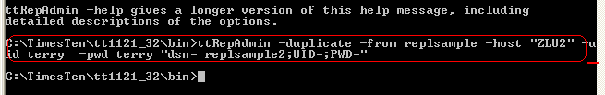

DOS> ttIsql "DSN=replsample2"

CALL ttRepStart;
CALL ttRepStateGet;

DOS>ttRepAdmin -duplicate -from replsample2 -host "ZLU2" -uid terry -pwd terry "dsn= replsample3;UID=;PWD="
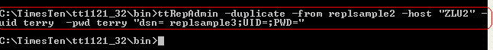

DOS> ttIsql "DSN=replsample3"

CALL ttRepStart;
call ttRepStateGet;

……………………

[ActiveMaster]INSERT INTO tab VALUES (1,'Hello');
[ActiveMaster]SELECT * FROM tab;
[StandyMaster]SELECT * FROM tab;
[Subscriber]SELECT * FROM tab;

Replication Practice Sample-2

DOS> ttIsql "DSN=masterds"

CREATE TABLE tab (a NUMBER NOT NULL,b NUMBER,c CHAR(8),PRIMARY KEY (a));

CREATE REPLICATION repscheme ELEMENT e TABLE tab MASTER masterds SUBSCRIBER subscriberds;

call ttRepStart;

DOS>ttIsql "DSN=subscriberds"

CREATE TABLE tab (a NUMBER NOT NULL,b NUMBER,c CHAR(8),PRIMARY KEY (a));

CREATE REPLICATION repscheme ELEMENT e TABLE tab MASTER masterds SUBSCRIBER subscriberds;

call ttRepStart;

Cache Group and Replication Scheme Practice Together

Check the Cache Group status
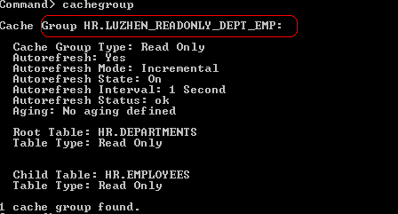

Check the Timesten status in another DOS window
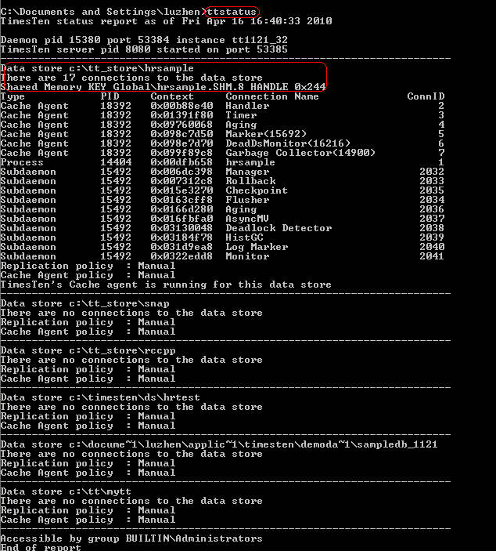

Host File

